**Instituto Tecnológico**

**y de Estudios Superiores de Occidente**

Reconocimiento de validez oficial de estudios de nivel superior según acuerdo secretarial 15018, publicado en el Diario Oficial de la Federación del 29 de noviembre de 1976.

Departamento de Electrónica, Sistemas e Informática

Maestría en Sistemas Computacionales



**Performance comparison of Deep Learning Models applied for Satellite Image Classification**

Trabajo recepcional que para obtener el grado de

Maestro en Sistemas Computacionales

Presenta: Carlos Alberto Cordero Robles

Asesor Dr. Iván Esteban Villalón Turrubiates

Tlaquepaque, Jalisco. Julio de 2020.

[La portada se deberá actualizar con la versión oficial disponible en: <https://www.iteso.mx/titulacionposgrados>]

[SI EL DOCUMENTO ES ESCRITO EN INGLES, se debe colocar la portada principal en inglés, y una segunda portada en español.]

Acknowledgments

I would like to acknowledge to:

My thesis advisor Dr. Ivan Villalón, who suggested me the topic for this document and always tried to find the way to unblock me with any blocker that appeared during the investigation.

The Mtro. Victor Martinez who provided good guidance in many aspects to improve the quality of this effort.

Luxoft that is the enterprise where I work and provided resources and flexibility to let me continue with my professional development.

Oracle for all the support in resources that made the realization of this project possible.

The "Instituto Tecnológico y de Estudios Superiores de Occidente (ITESO)" for the resources provided for the development of this research. Additionally, to the "Consejo Nacional de Ciencia y Tecnología (CONACYT)" for the financial support received through the grant number 498325.

AGRADECIMIENTOS

El autor desea dar las gracias a:

Mi asesor de tesis Dr. Ivan VIllaón, por sugerirme el tema de tesis para este documento y siempre busco maneras de desbloquearme en todos los contratiempos que surgieron durante la investigación.

Al Mtro. Víctor Martínez por todos sus consejos y guía en muchos aspectos para mejorar la cualidad de este esfuerzo.

A la empresa Luxoft en la cual laboro por los recursos y flexibilidad que me permitió continuar con mi desarrollo profesional.

A Oracle por todo el soporte en recursos que hicieron posible la realización de este proyecto.

Al "Instituto Tecnológico y de Estudios Superiores de Occidente (ITESO)” por los recursos provistos para el desarrollo de esta investigación. Adicionalmente, al "Consejo Nacional de Ciencia y Tecnología (CONACYT)" por el soporte financiero recibido a través del número de autorización 498325.

Dedication

I would like to dedicate this project to:

My great family that has always supported my ideas and projects.

Dedicatoria

Me gustaría dedicar este proyecto a:

Mi gran familia que siempre ha apoyado mis ideas y proyectos.

Abstract

Satellite images classification is important for applications that involve the distribution of the human activities. Such distribution helps the governments to determine the best places to expand cities avoiding problems related to natural disasters or legal constrains. Currently, existing few agencies in charge of image classification and the area to cover is enormous. Therefor an automation of this process is necessary for this task otherwise, it will take an eternity to perform this task manually. On the other hand, detection and classification algorithms used before Machine Learning (ML) have not shown good result classifying this specific sort of images. However, latest approaches for image classification using Convolutional Neural Networks (CNN) have shown quite accurate results. In this research, we analyses the performance in four different CNN architectures used for satellite image classification. We use a dataset provided in 2017 by IARPA names IARPA fMoW. It contains more than two thousand images belonging to 62 classes already separated in train and validation.

The solution was implemented in Python using the Keras and Tensorflow libraries. The research was divided in two parts: Hyperparameters optimization and full dataset classification. The first part use a sample of the dataset near to one thousand images. The models are trained using this small dataset to determine the best hyperparameters. The evaluation is based on visual examination with the help of the tool Tensorboard and metrics. After having these results, for the second part of the research the models that showed good performance were trained using the previous hyperparameters and the entire dateset.

The model selected after the analysis was XXXXX with a final accuracy of XX.

Resumen

Las imágenes satelitales y su clasificación son importantes en diversas aplicaciones que involucran la distribución de las actividades humanas. Dicha distribución ayuda a los gobiernos a determinar la mejor ubicación para la construcción en áreas específicas para evitar problemas relacionados con desastres naturales o conflictos legales. Actualmente no existen muchas agencias destinadas a este propósito y considerando lo enorme que es el área por cubrir se llega a la conclusión que es necesario automatizar el proceso para esta tarea. Esta tarea seria eterna si se realiza manualmente. Por otra parte, los algoritmos de detención y clasificación usados antes de “Machne Learning” no han mostrado buenos resultados en la clasificación de este tipo de imágenes. Un método que ha mostrado ser bastante preciso en tareas de clasificación son las Redes Neuronales Convolucionales (CNN). En esta investigación analizo el desempeño de cuatro diferentes modelos de CNN para esta tarea específica de clasificación de imágenes satelitales. El “dataset” utilizado es uno provisto el 2017 por IARPA fMoW. Este “dataset” contiene más de doscientas mil imágenes pertenecientes a 62 clases y ya previamente separadas en Entrenamiento y Validación.

La solución fue implementada en Python usando la librería de Keras ya integrada a Tensorflow. La investigación se divide en dos partes. La primera parte es usando una muestra del “dataset” original cercana a las mil imágenes, para así determinar los mejores hiperparametros y los métricos de cada modelo, con la ayuda de la herramienta Tensorboard. Después de tener los resultados, los modelos que mostraron tener buenos resultados fueron entrenados usando el dataset completo y los hiperparametros antes encontrados, para al final solo quedar con el mejor candidato.

El modelo seleccionado después del análisis fue XXXXX con una eficiencia final de XX.

Content Table

Maestría en Sistemas Computacionales 1

1. INTRODUCTION 14

1.1. Background 15

1.2. Justification 15

1.3. Problem 16

1.4. Hypotesis 16

1.5. Objective 16

1.5.1. General Objetive: 16

1.5.2. Specific Objective: 16

1.6. Scientific or technologic share/innovation 17

2. State Of Art or the technique 18

2.1. Satellite Image classification based on unsupervised methods 19

2.1.1. A novel two-tier paradigm for labeling water bodies [13] 19

2.2. Satellite Image classification based on supervised Machine learning 20

2.2.1. Pattern Recognition Scheme for Large-Scale Cloud [17] 20

2.2.2. Improved Machine Learning Methodology for High Precision Agriculture [16] 21

2.3. Satellite Image classification based on Deep Learning 22

2.3.1. DEEP LEARNING NEURAL NETWORKS FOR LAND USE LAND COVER MAPPING [14] 22

2.3.2. Dense Cloud Classification on Multispectral [15] 23

2.3.3. Satellite Image Classification with Deep Learning [18] 24

2.3.4. Deep Learning for Cloud Detection [19] 25

3. Theoric/conceptual framework 27

3.1. Artificial Intelligence (AI) 27

3.1.1. Machine Learning 28

3.1.2. Deep Learning 29

3.2. Convolutional Neural Network (CNN) 30

3.2.1. Introduction 30

3.2.2. Convolutional Network 31

3.2.2.1. Local receptive fields and Shared weights 31

3.2.2.2. Sub-sampling 32

3.2.2.3. Fully connected layer 32

3.2.2.4. CNN Learning 32

3.2.3. ResNet-152 [8] 33

3.2.4. InceptionV3 [9] 33

3.2.5. Xception [10] 33

3.2.6. DenseNet-161 [11] 33

3.3. Classification Metrics 33

3.3.1. Accuracy 33

3.3.2. Precision 33

3.3.3. Recall 33

3.3.4. F1-Score 33

3.3.4.1. Macro-F1 34

3.3.5. Hamming Loss 34

3.3.6. Jaccard Score 34

3.3.7. Log loss 34

3.4. Machine and Deep Learning libraries 34

3.4.1. NumPy 34

3.4.1. TensorFlow and TensorFlow-GPU 35

3.4.2. Keras 35

3.4.3. Tensorboard 35

3.4.4. Pandas 35

3.4.5. SKLearn 36

4. DESARROLLO METODOLÓGICO 37

4.1. Levantamiento de requerimientos 38

5. RESULTADOS Y DISCUSIÓN 39

5.1. Resultados 40

5.2. Discusión 40

6. CONCLUSIONES 41

6.1. Conclusiones 42

6.2. Future Works 42

LIST OF FIGURES

Figure 1Tow-tier image labeling scheme 19

Figure 2 Vineyard split with tiles of 30x30px 21

Figure 3 Province of Manitoba constructed with snipets of satellite images 22

Figure 4 Tiling process 2224x224px with an overlap of 1/2 (224/2 = 122px) 22

Figure 5 Deep Learning NN Produced LULC Map 23

Figure 6 Examples of 32x32 image patches of 13 classes 23

Figure 7 Architecture of the CloudNet, pretrained kernels are blue 24

Figure 8 Window classifier applied to thunder cells (Xanxi province). Left: Original image, Middle: Label map CNN, Right: Label map SVM 24

Figure 9 The deep earning system for classifying satellite imagery. 25

LIST OF TABLES

Table 1 Selected features for Pixel-Based classification 20

Table 2 Kappa Statistics and Overall Accuracy [k (OA%)] for the Selected Landmarks 20

Table 3 Comparative Results table with the previous Study and local Vineyards application 21

Table 4 Pixel accuracy for the different networks 26

LISTA DE ACRÓNIMOS Y ABREVIATURAS

[Del lado izquierdo va el acrónimo o abreviatura y del lado derecho su significado. La columna de en medio se deja en blanco. Al final, se deben quitar los bordes de la tabla]

|  |  |  |
| --- | --- | --- |
| IARPA fMoW |  | Functional Map of the World |
| ML |  | Machine Learning |
| DL |  | Deep Learning |
| CNN |  | Convolutional Neural Networks |
| SVM |  | Support Vector Machine |
| PCA |  | Principal Component Analysis |
| LDA |  | Linear Discrimination Analysis |
| SURF |  | Speeded Up Robust Features |
| SIFT |  | Scale Invariant Feature Transform |
| HOG |  | Histogram of Gradients |
| POP |  | Province of Manitoba |
| OLI |  | Operation Land Imager |
| TIRS |  | Thermal Infrared Sensor |
| IR |  | Infra-Red |
| UAV |  | Unmanned Aerial Vehicle |
| MSG |  | Meteosat Second Generation |
| NN |  | Neural Network |
| AI |  | Artificial Intelligence |
| TF |  | Tensorflow |
| LULC |  | Land use/Land cover |
|  |  |  |

# INTRODUCTION

Several applications for the satellite images are related to public works. They contribute to the development of the civilization and its life quality, although they are extremely expensive. One construction can cost easily thousands of millions of dollars. A well planification can be de difference between a good usage of the building or a waste of money that can be lost because the accessibility or a natural disaster.

To plan and determine correct strategy for the public works construction it is required a classification of the current public works and “land use” distribution.

The methodologies used before ML have not shown good results classifying this kind of images. Based on those ML results, in this research we are going to use and compare the behavior of four different DL models in order to find the best accuracy possible.

The models used the dataset provided for the challenge fMoW in 2017 that contains 62 classes already labeled and separated in training and validation. This is a multispectral dataset, however we will work only with the classic RGB bands. Nevertheless, a dataset preparation is required. As a future work the use of more bands is expected.

## Background

This research is based mainly in 2 previous researches. The first one is entitled “Satellite Image Classification with Deep Learning” [7]. In this paper Mark Pritt and Gary Chern used the dataset provided from IARPA fMoW. They got an accuracy of 83% using a hybrid model using four models Resnet-152 [8], InceptionV3[9], Xcepetion [10] and DenseNet-121[11]. The models were trained using one epoch. Data augmentation was required because satellite images don’t follow any alignment. The dataset was expanded by eight by flipping the image horizontal a vertically and rotating the image 90°, 180° and 270° degrees. The output of the model was attached to the model’s outputs to create a hybrid model that categorize the images.

The second paper entitled “Functional Map of the World” [12] is related with the dataset itself. This paper describes the characteristics of the dataset. As it is explained, this is a multispectral dataset and the images goes from three to eight bands. In addition, the dataset contains a metadata with valuable geographic information as well as the sensor information.

## Justification

Satellite images and its classification is important for many applications that involve the distribution of the human activities. Public works is one of the most representative and expensive responsibilities of the governments and in some cases for some investors. At the same time, they represent an important factor for the population development and distribution. Unfortunately, these sorts of investments are overwhelmingly expensive. Just here in México two constructions are in progress and together will cost more than 150,000 million of Mexican pesos (more than 7.5 hundreds of millions of dollars) [1][2]. This is just to give an example of the cost that can take a public work of this magnitude. Although, the public works have a purpose and if they are well planned the benefits for the enclosed population and the life quality tends to improve. On the other hand, if the public work is not well planned and geographically well distributed it will directly impact the enclosed population as well as the economy of the country.

Another controversial example is the “Nuevo Aeropuerto Internacional de México (NAIM)” that was recently cancelled because floods probabilities. We can even confirm this information and many other environment hazardous impacts in the document resolutive analysis SGPA/DGIRA/DG/09965 [3] that shows that in some periods of the year the airport remains covered by water, in addition the airport would be near to areas were endemic and extinction endangered species lives. The cost for the cancellation of this airport was 120 thousand millions of Mexican pesos (6 thousand millions of dollars approximately) [4]. Those are the kind of mistakes related with constructions allocation that can be avoid with good planification and distribution of public works.

Nevertheless, this situation is not only limited to government public works. Many private constructions focused on recreation are also involved. One example is the Mercedez-Benz stadium in New Orleans also called the superdome. In 2005, this city suffered the floods caused by the hurricane Katrina and that was granted with a renovation that will cost 450 millions of dollars [5].

This take us to other important point when a construction is planned. As we have seen this investments costs millions of dollars and well applied they will retrieve a lot of incomes to the population and the nation in general. On the other hand, if they are not well located or geographical distributed or if they are endangered for any natural disaster it will result in one enormous catastrophe for the stakeholders and the people that inhabit in the area.

In order to plan it is required to map the current distribution of the public works and constructions. One powerful resource that can be used are the satellite images. Although the task of classification is most of the time performed manually and in order to categorize all the entire earth surface will be quite exhausting. The importance of this task has triggered many challenges [6] that are not limited to any technology and the goal is to obtain the higher performance in detection and classification of many kind of images including satellite images.

The latest years neural networks technologies have shown good results categorizing images, specifically Deep Learning models that involve many layers of neurons. This technology is costly and involve hours or even weeks of computing. That is why it is highly valuable to determine if this technology has good result with a specific dataset. In this case in particular, a dataset of satellite images.

## Problem

The problem faced in this research is a classic classification problem related with satellite images and the method of classification is DL. The dataset taken as reference is IARPA fMoW that provides 62 classes. The CNN architectures used are Restnet-152, InceptionV3, Xception and DensNet-161 [18]. Classification of satellite images is quite important for the civilization distribution. The latest years DL is a state-of-the-art technology that has shown outstanding results in image classification. Currently, several DL architectures and models are accessible, and the goal of this research is to compare the behavior of four different architectures to determine the most appropriated for this satellite image datasets.

## Hypotesis

[Si la investigación lo justifica]

## Objective

#### General Objetive:

To find the highest accuracy using four different CNN architectures and working with a labeled satellite images dataset with 3 bands.

#### Specific Objective:

To accomplish the general objective, are required the following specific objectives:

* To obtain a labeled dataset to be able to stimulate the CNN models with such information.

* To preprocess the dataset to accomplish the specifications of every Model.

* To build or get every model and adapt it to the number of classes that are handled in our dataset.

* To define a strategy to manage the dataset. Maybe it’s required to separate the images in tiles or maybe it is a good idea to start working with a small batch of images.

* To find the best hyperparameters for every CNN model.

* Evaluate the behavior of every CNN using metrics as F1-Score, Hamming Loss, Jaccard Score and Log loss.

## Scientific or technologic share/innovation

This document will share the behavior of four different CNN architecture using a satellite images dataset.

# State Of Art or the technique

We can find in recently researches related to the classification of satellite images using DL. Some of them are focused in a specific area of study like land usage or bodies of water. Some of them are even more specific and would focus their work in a specific topic like areas for agriculture and cropping. On the other hand, we can find paper related with a more general detection of human construction that not only detect land usage areas but also public works.

One particularity that have the satellite images is that some images contain multispectral information, that means that the image is not having only the classic RGB layers but also near and far infrared that have shown good result making visible bodies of water. Some other images have eight layers and some of them have the capacity to trespass some centimeters the surface of the earth, nevertheless not all the investigations are using such layers, most of them are still using only the classic RGB layers.

One common problem that exist for the satellite images that only work with the classic RGB layers are the clouds. It is something that cannot be removed an always going to be a problem of the classic layers. Some papers have even focused their investigation on the detection of clouds and categorizing its shape and texture.

Another aspect that we can find in previous works are the usage of hybrid models. Sometimes it is possible to option more accuracy if we add to the system not only the image but also the geographical information or any other post processing that can be performed with dense layers or SVM.

## Satellite Image classification based on unsupervised methods

## A novel two-tier paradigm for labeling water bodies [13]

In 2017 Janice Aroma and Kumudha Raimond from the University of Karunya described the steps required to label satellite images. Labeling is an unsupervised method of clustering required to perform supervised training. The study doesn’t end just with the labeling, it also applies a supervised classifier to recognize seasonal water bodies.

In this paper is explained the necessity of intelligent models to determine and measure the damage and post hazard because the surveys and field works insitu represent a heavy time consumption. Satellite images are the opposite problem, they contain a lot of information at every band and the task now is to extract the features with accuracy and in the shortest time possible.

Currently the traditional methods for classification PCA and LCA are dependent of statistical color features although the satellite images commonly come from different satellites that have different sensors then using local discriminators instead of global discriminators have shown been more robust. The local discriminators used for image classification are SURF, SIFT and HOG.

Unfortunately, the process to obtain the features is still not efficient. In general, the most highly used labeling methods are pixel based that are laborious and complex. Then this paper proposes a method named Two-tier labeling scheme. In the Figure 1 we can see an example were one specific water body was taken for this study and the first tier was the Local monsoon pattern the second one was the water body area. Obtaining descriptors provided from these two tiers they were able to label different states of the water body including disasters or hazardous events.

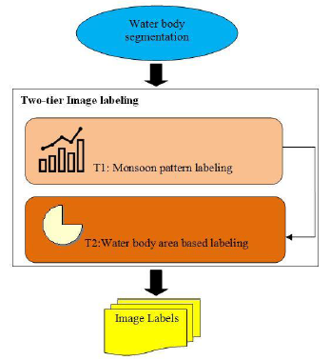

Figure 1Tow-tier image labeling scheme

## Satellite Image classification based on supervised Machine learning

## Pattern Recognition Scheme for Large-Scale Cloud [17]

In 2018 Adrian Pérez-Suay and Jordi Muñoz-Marí used machine learning for cloud detection over landmarks using MSG satellites images. MSG SEVIRI takes an image every 15 min with 12 spectral channels and the size of the images is 3712x3712. The dataset used was from the year 2010 with 200 landmarks and 7 million of images.

The labels used for this experiment were Space/no data (0), water (50), land (100), cloud (200) and the ML classifier method was SVM.

The features extracted were related with reflectance, brightness and temperature. IR channels provide information about the temperature of clouds, surface, and land. Some NIR channels helps separating between cloud and land and some IR channels help to detect fog and log clouds. At the end only 16 features were used, we can see them listed in Table 1.

Table 1 Selected features for Pixel-Based classification

|  |  |  |  |
| --- | --- | --- | --- |
| Number | Features | Day | Night |
| 1 | R1 VIS 0.6 µm | Yes | No |
| 2 | R2 VIS 0.8 µm | Yes | No |
| 3 | R3 NIR 1.6 µm | Yes | No |
| 4 | R4 IR 3.9 µm | Yes | Yes |
| 5 | BT7 IR 8.7 µm | Yes | Yes |
| 6 | BT9 IR 10.8 µm | Yes | Yes |
| 7 | BT10 IR 12.0 µm | Yes | Yes |
| 8 | Cloud Test: R2/R1 | Yes | No |
| 9 | Snow Test: (R1-R3)/(R1+R3) | Yes | No |
| 10 | NDVI: (R2-R1)/(R2-R1) | Yes | No |
| 11 | *mean3x3*(R1) | Yes | No |
| 12 | *std3x3*(R1) | Yes | No |
| 13 | *mean5x5*(R1) | Yes | No |
| 14 | *std5x5*(R1) | Yes | No |
| 15 | *mean3x3*(BT9) | Yes | Yes |
| 16 | *std3x3*(BT9) | Yes | Yes |

In order to give more accuracy to the problem it was divided in different scenarios depending on the time of the day and the zone. The day was divided in four ranges and the landmarks were assigned to twelve zones. The results are presented below in Table 2 were we can see that twelve zones were selected (Name) and four days divisions are evaluated according to the light intensity of the day: High Light, Medium Light, low light and Night.

Table 2 Kappa Statistics and Overall Accuracy [k (OA%)] for the Selected Landmarks

|  |  |  |  |  |  |  |
| --- | --- | --- | --- | --- | --- | --- |
| Name | #LM | High Light Sza<=szam | Medium Light szam<=sza<=80 | low light 80<=sza<=90 | night sza>=90 | global |
| Ad Dakhla (Morocco) | 0 | 0.62 (83.24) | 0.71 (87.03) | 0.63 (83.51) | 0.65 (85.78) | 0.66 (85.35) |
| aqaba2 (saudi arabia) | 14 | 0.50 (82.74) | 0.56 (83.34) | 0.57 (84.95) | 0.65 (90.06) | 0.59 (86.65) |
| azores5 (portugal) | 17 | 0.72 (87.61) | 0.64 (86.20) | 0.56 (80.98) | 0.56 (79.86) | 0.61 (82.94) |
| chad2 (chad) | 48 | 0.76 (87.94) | 0.74 (87.09) | 0.64 (81.97) | 0.58 (78.75) | 0.65 (82.83) |
| danger (south africa) | 63 | 0.82 (90.89) | 0.81 (90.36) | 0.68 (84.22) | 0.63 (81.57) | 0.71 (85.64) |
| grampian (scotland) | 83 | 0.70 (89.99) | 0.69 (88.90) | 0.57 (81.92) | 0.48 (78.32) | 0.57 (82.95) |
| libreville (gabon) | 107 | 0.69 (87.93) | 0.73 (89.52) | 0.69 (87.34) | 0.68 (88.25) | 0.69 (88.40) |
| messina (sicilia) | 120 | 0.80 (90.09) | 0.80 (89.92) | 0.73 (86.47) | 0.71 (85.73) | 0.75 (87.61) |
| nasser2 (egypt) | 131 | 0.57 (89.16) | 0.59 (88.33) | 0.63 (90.08) | 0.71 (94.17) | 0.64 (91.52) |
| rhodes (greece) | 154 | 0.80 (91.54) | 0.77 (88.73) | 0.72 (86.44) | 0.72 (86.50) | 0.75 (88.05) |
| tenerife (spain) | 177 | 0.77 (88.46) | 0.71 (85.41) | 0.63 (81.30) | 0.67 (83.18) | 0.69 (84.68) |
| Valencia (spain) | 190 | **0.83 (91.59**) | **0.84 (92.18)** | **0.76 (87.88)** | **0.73 (86.72)** | **0.78 (89.01)** |

Best Results are highlighted in bold.

## Improved Machine Learning Methodology for High Precision Agriculture [16]

In 2018 Jérôme Treboux and Dominique Genoud members of the Institute of Information Systems of the University of Applied Sciences, Valais Sierre, Switezerland developed a method using ML to improve from 89.6% of accuracy (using methods based in color analysis) to 94.27% in classification of vineyards and roads. These sorts of analysis are important to increase the productivity in agriculture and determine the correct amount of inputs (water, fertilizer, etc.) in the correct place.

The research used infrared images taken from a UAV that in this case was a drone that can fly over the fields carrying treatment products.

The dataset were five images of five different vineyards in Valais, Switzerland taken by a drone. An expansion of the dataset was performed dividing the images in tiles of 30x33 pixels (Figure 2) to end up with 13, 005 images manually labeled. The categories to classify were: Road, Vineyard or Other. We can notice in Figure 2that using tiles of 30x33px some objects are mixed but rarely.

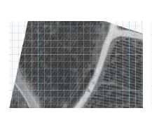

Figure 2 Vineyard split with tiles of 30x30px

The dataset was divided 90% for training and 10% for validation. Only 16 features were taken from the images from the following three categories, First Order Statistics (Min, max, mean, geometric mean, sum, variance, etc.), Tamura (Granularity, Contrast, kurtosis of directional, etc.) and Haralick (Statistical features based on gray-level).

The final overall accuracy of the algorithm is of 94.275% that shows an improvement from the preview’s studies (Table 3) that showed accuracy near to 90%.

Table 3 Comparative Results table with the previous Study and local Vineyards application

|  |  |  |  |
| --- | --- | --- | --- |
|  | Best detection within the study | local vineyar 1 | local vineyar 2 |
| Accuracy Std err | 96.06% N/D | 90.02% ± 1.17% | 89.6% ± 1.01% |

## Satellite Image classification based on Deep Learning

## DEEP LEARNING NEURAL NETWORKS FOR LAND USE LAND COVER MAPPING [14]

This research performed in 2018 by Christopher D. Storie and Chrisotpeh J. Henry from the University of Winnipeg, had the objective to classify the land use/land cover of Manitoba Canada. GeoManitoba that is department of POM requested such classification and continue doing it human bases semi-automated showed to be an unsustainable task (as much as 4800 work hours) because it has to be performed yearly.

The stakeholders had interest in this sort of research because it is possible to get information related with flood forecasting, urban and rural land use planning, resource management, and disaster management and planning.

POP provided a multispectral (6 bands) Landsat database provided by GeoManitoba of 19,039 images belonging to 18 classes for the years 1993, 2000 and 2004. The requirement was to use the model to tag all the not tagged regions of those years.

The model used was VGG-16 that has an input layer of 224x244.

The first step was to construct the region of Manitoba using satellite images and matching them to construct an image with the entire map as we can see in Figure 3.

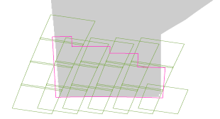

Figure 3 Province of Manitoba constructed with snipets of satellite images

After that the map was divided in tiles of the size of the input layer of the model (224x224) but overlapped the half size of the window (112 pixels) as we can see in Figure 4.

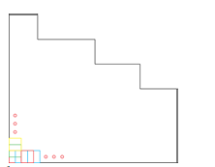

Figure 4 Tiling process 2224x224px with an overlap of 1/2 (224/2 = 122px)

The dataset was divided in 18,054 images for training and 958 for validation. Since the dataset was too small it was required to apply transfer learning. The training plus the mapping process took near to 10 days and the accuracy was the following: 82.5% (1993), 81.2% (2000) and 79.5% (2004). Using the classification with Deep Learning NN ever tile was classified and colored to obtain a complete LULC Map as illustrated in Figure 5.

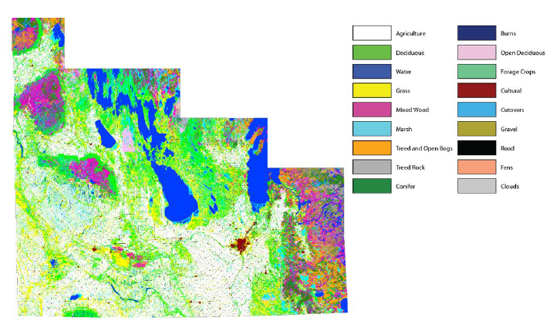

Figure 5 Deep Learning NN Produced LULC Map

## Dense Cloud Classification on Multispectral [15]

In this research by University of Dortmund by the Image Analysis Group a methodology to categorize 13 cloud classes (also called genera) was performed based on a small dataset (147 images) of Landsat 8 satellite images. The images provided by the dataset used two different sensors OLI that has nine band from 435nm to 2294nm and TIRS that has two bands from 1060nm to 1251nm.

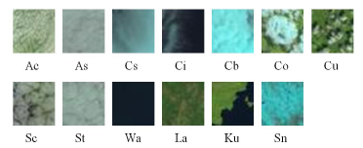

Figure 6 Examples of 32x32 image patches of 13 classes

The dataset of 147 images (every image with a range between 6000 and 8000 pixels) was expanded cropping it in squares of 320x320 pixels and down sampling the squares to 32x32 pixels to end up with an expanded dataset of 9578 images. This expanded dataset was augmented with rotations and mirroring to obtain one thousand images per class, thirteen images classes in total that were distributed 90% for training and 10% for validation. The labeling was performed manually in few sessions, in Figure 6 we can see examples of the labeled images.

For the CNN they used a customized Alex-Net. The customization consisted in removing all the layers excepting the first two Convolutional layers and their polling. Transfer learning was applied for these two layers from imageNet database. Finally, they added an untrained Convolutional Layer and a fully connected layer and used Adagrad optimizer for the training, they called this model CloudNet (Figure 7) About training time, they reported that the training of 10,000 epochs took near to ten minutes.

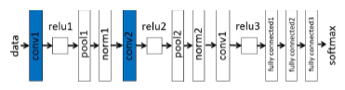

Figure 7 Architecture of the CloudNet, pretrained kernels are blue

For the SVM they used SURF and one additional input for the SVM was the color histogram of the image, this final training took between 30 and 60 min.

The accuracy using RGB layers was 85.8% after adding the IR layer the accuracy slightly raised to 86.1% and finally adding the SVM classification the final accuracy was 95.4%. In Figure 8 we can see an example of labeling using CloudNet CNN and CloudNet CNN plus SVM over one satellite image of the province of Xanxi.

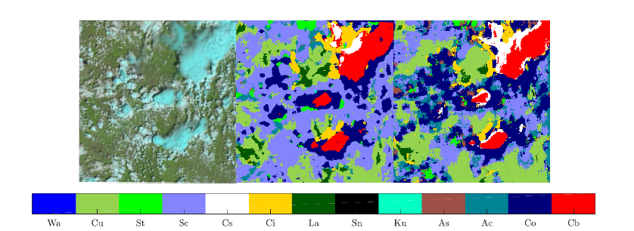

Figure 8 Window classifier applied to thunder cells (Xanxi province). Left: Original image, Middle: Label map CNN, Right: Label map SVM

## Satellite Image Classification with Deep Learning [18]

In 2017 Mark Pritt and Gary Chern from Lockhead Martin Co. developed a classification DL system in python using Keras and Tensorflow libraries and a GPU NVIDIA Titan X. They are classifying satellite images, because the geographic expanses to be covered are great and the analyst available to conduct the searches reduced it is required to automate the process.

The dataset used was the one provided by the Intelligence Advanced Research Projects Agency (IARPA), the dataset is named the Functional Map of the World (fMoW) that contain 62 classes already labeled. The images contain from 3 to 8 bands and include metadata, although for this experiment only 3 bands were used. The dataset already comes divided in training and validation. For training the dataset was augmented eightfold by flips and 90°, 180° and 270°degree rotations.

They system that they proposed is an ensemble of CNNs that receive a processed (preprocessed) image and followed by a classic NN at the end the maximum probability determines de classification (Figure 9).

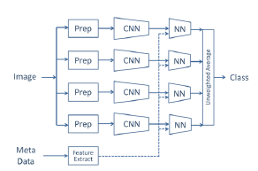

Figure 9 The deep earning system for classifying satellite imagery.

The preprocessing is needed because the satellite images in general don’t match the CNN input size of 224x224 or 299x299 then they have to be cropped and adjusted. The bonding box is part of the metadata information and it is used to perform the cropping.

The CNN models selected were DenseNet-161, ResNet-152, Inception-v3 and Xception. The metadata was normalized and used as an input for the NN models. Transfer learning was applied from ImageNet.

For training, the CNN models were trained only one epoch and for the NN twenty epochs were needed. The final results showed an accuracy of 83% and F1 score of 0.797.

## Deep Learning for Cloud Detection [19]

In this research performed in the University of Toulouse a comparison between DL methods used with classical handcrafted features and classical CNN is performed for cloud detection.

The detection consists in labeling every pixel of an image indicating if that pixel belongs to a cloud or not. The first detectors took the descriptors from the morphology of the shadow or from dedicated spectral bands, although they showed a lack of generalization and low robustness, the next generation of detectors used handcraft features that the engineer itself select for DL this is not required and the results are even better.

The dataset is 10,000 images from SPOT 6 satellite that provide 4 band (RGB and NIR) granted by the Airbus Defense and Space.

The comparison was made between the CNN solution against four classic methods: RGBI raw pixel values, band ratios, Gabor coefficient and discrete cosine transform (DCT) coefficients.

The selection of features critical form the classic methods, some of these features are noise sensitive, require neighboring information and many times need physical correction, nevertheless band ratios have shown good results. Band-ratios were processed at three different spatial resolutions (60m, 120m, 240m). Gabor is more used for textual features of the image, for this study 48 features were taken and for DCT 192 features that were the input for a classic NN to determine de classification. For the CNN this is not required but instead of having features it is required to take an input of 32x32 (patch) were the pixel to analyze is just at the center. The CNN used was like the one used in CIFAR-10. The results are shown below.

Table 4 Pixel accuracy for the different networks

|  |  |  |  |  |
| --- | --- | --- | --- | --- |
| Input Type | Network | accuracy | Recall | Precision |
| Gabor | ANN | 77% | 43% | 66% |
| Raw pixels | ANN | 83% | 68% | 77% |
| featrues | ANN | 81% | 68% | 80% |
| SueprPixels | ANN | 83% | 69% | 80% |
| dct | ANN | 83% | 75% | 80% |
| pathches | CNN | 86% | 75% | 81% |

In general, the CNN (patches) got slightly better results 86%, we have to consider that the work to identify the features is not required when working with CNN.

# Theoric/conceptual framework

This chapter describe some concepts that were used during the research. Some of them are methods or techniques followed to create and train the architectures some other ones are metrics used to evaluate such architectures. Many topics mentioned are related with Artificial Intelligence, in particular CNN architectures and the platforms used to train and evaluate its performance.

## Artificial Intelligence (AI)

Artificial intelligence is a discipline found in 1956 by John McCarthy. The objective of this discipline is to mimic the way how humans solve problems or to solve problems that at this time only humans were able to solve and therefore were related with intelligence [20].

Even before this discipline was formalized, we can find many examples in the history talking about automatons and early concepts of robots that had specific task [21]. Many of them were simply mechanic devices with shapes of humans or animal that had the task to answer a specific question performed by a user or to execute a movement depending on a user action.

John McCarthy defined IA as a branch of computer science which deals with the study and design of intelligent agents that perceives its environment and takes actions which maximize its chances of success [22]. Many of the problems related with intelligence included situation that required experience, reasoning to define a solution or inferring and quick response. In addition, these systems can take decisions based on priorities to overcom complexity and ambiguity in problems. The goal of this discipline is to build computer programs that exhibit the mentioned intelligence behavior.

Normally, the languages used for IA are not oriented to handle numeric information because the input for this system is qualitative information.

AI is divided in four main components:

* Expert Systems

* Heuristic Problem Solving

*Natural Language Processing

* Vision

Expert systems optimized the solutions to handle it as an expert and obtain the best possible performance. Heuristic problem solving find the solution among a group of possible solutions evaluating them and applying a sort of heuristic to find the closes option to the optimal. Natural language processing handles the communication between the machine and the human using human languages. Vision is dedicated to shapes, features, etc. recognition. [22][23]

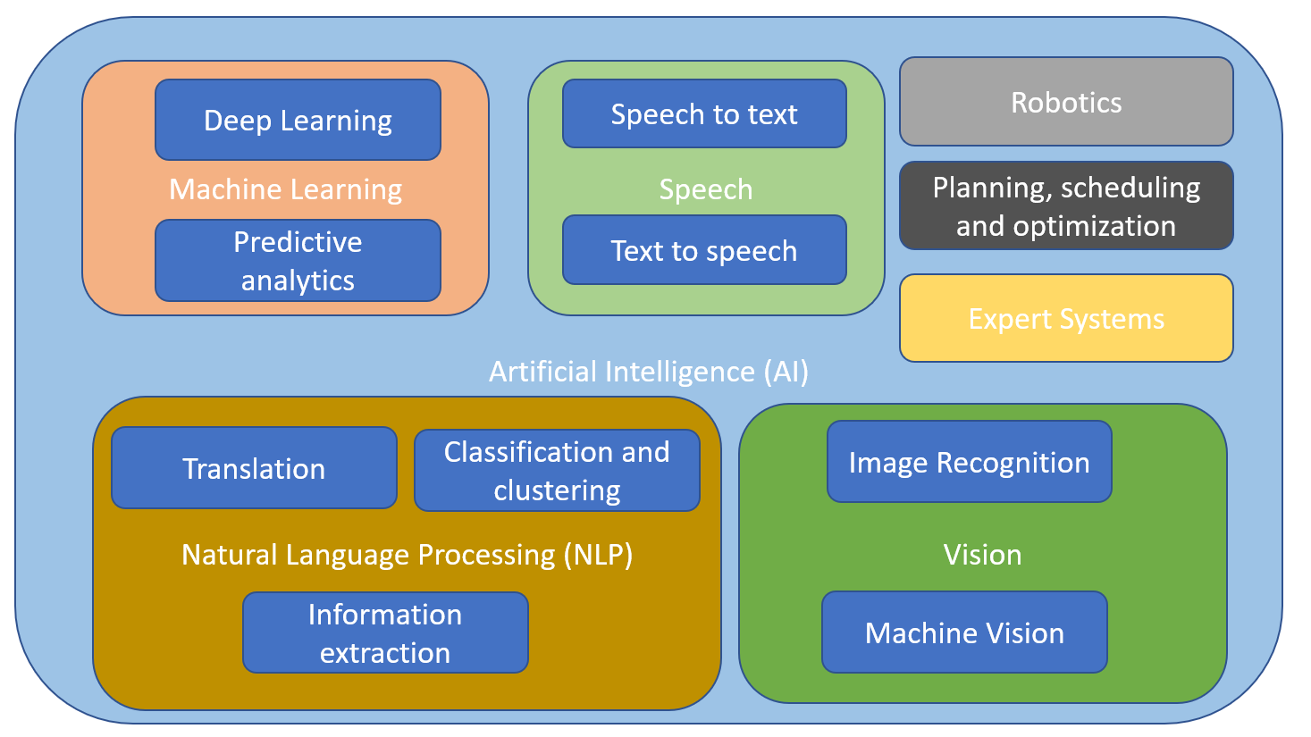

Figure 10 Artificial intelligence disciplines map

AI, Machine Learning and Deep Learning are many times confused each other. Although, Deep Learning is a branch of Machine Learning and Machine learning is a branch of Artificial Intelligence as we can see in Figure 10 [20]. Artificial intelligence is the discipline that develop programs that achieve solutions analogically to the humans. On the other hand, Machine and Deep Learning are methods that solve problems that need to replicate the process of human learning.

## Machine Learning

The first formal development of neural networks started in 1943 by McCulloch and Pitts that created models of biological neurons using circuits that can perform computational tasks [24]. Continuing with hes work in 1969 Minsky and Paper published a book called *Perceptrons* were they described this model but also showed some disadvantages that demotivated the effort. In the early eighties was discovered a new method to train the neurons called back-propagation and the new development of more powerful computers renewed the interest for such topic.

Artificial Neural Networks is one of most mighty models to learn, to generalize and to cluster. They have also the capacity to be computed in parallel. Nevertheless, the lack of knowledge that we still have about the neurons in the biological systems limits the development of artificial neural networks to an oversimplified version of the biological counterpart [24]. We can understand a neural network as a bunch of processing units called neurons that send signals each other over weighted connections. Then each unit receive a weighted input signal from a neighbor’s units or external sources and processes all these inputs to compute one output that can be an input to another unit.

All the units have the same structure and functionality, but we can divide them in three types. The first type are the input units that takes the external data. We also have the output units that send signals outside the system and between those two types of units we have layers of hidden units (Figure 11).

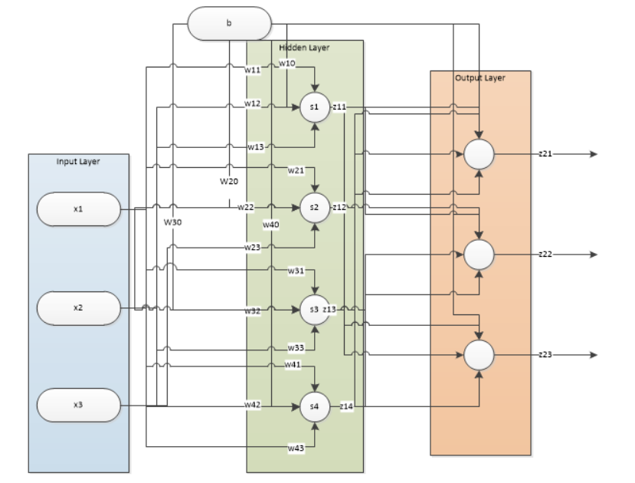

Figure 11Neural network topology

We can consider that every input for the neuron contribute plus an offset that is called bias. Although the output of the unit is not only the addition of this weighted signals, most of the neurons have an activation function that receive this addition as input to process an output.

To train the system we need a table with the value of the desired outputs for specific inputs. The goal is to adjust the weights in order to make the predicted outputs match the desired outputs. The difference will be considered as the error. Therefore, the weights must be adjusted in a process called *training*.

## Deep Learning

Deep Learning is a branch of Machine learning. ML and DL are methods that achieve a solution based on learning procedures.

The basis of DL is the same than ML although we shall take in consideration that DL handles multiple hidden layers [25]. ML has achieved many impressive results the last decades but the last years some DL architectures have shown better result in some areas in specific. These results have a lot of sense if we take in consideration that IA goal is to mimic the way how humans solve problems. To solve problems the human process the information with the brain that has billions of neurons, then it is not a surprise that some problems in particular required more neurons to be solved [20].

When we are trying to make a trainable system to obtain a binary deduction according to a bunch of inputs, then ML is enough to compute the solution. But many of the activities that realize the human are quite more complex than that. Our brain is a marvel and even when we are doing something that seems to be easy for us, like catching a ball, it is a very complex task if we analyze all the small task that the brain had to perform. In this example, the brain first has to identify that the thing that is approaching is a ball and determine how far is the objective from the user position. In addition, it has to infer that it is approaching and send signals to the actuators to place the hand in a place that cross the trajectory of the ball. This for sure is an activity that we can perform without suffering a headache but behind this simple task the brain is stimulating many neurons to make this happen and that is basically the philosophy of DL.

Deep Learning then can be used for task that cannot be achieved with simple architectures of ML and that are elementary for a human like: image recognition, emotions predictions, process of natural language and regression of complex functions.

## Convolutional Neural Network (CNN)

## Introduction

When talking about image recognition prior works were based on hand-designed features that gather important information form the image. This method ignored many unnecessary information that comes with the input itself and make the task easier to process [26]. After having selected manually the features a NN fully connected is trained to categorize the image into the corresponding class. The CNN is a system that avoid the necessity to gather some hand-designed features. The CNNs let the backpropagation training generate the feature extractor that takes the features from the images.

CNNs are part of the DL methodologies and follows the same logic that ML but including more hidden layers. Then in theory we can achieve this task of obtaining the feature extractor just creating a highly dense fully connected network. Nevertheless, the complexity of some problems makes this not possible or quite complicated just using a fully connected architecture. For example, images and spoken words are heavy inputs with many variables (every channel of every pixel is an input for example). If we consider a hidden layer of hundreds of neurons that will mean thousands of weights to be processed just for one layer and we have stablished that many layers are going to be needed. This will impact directly in the memory of our system [26].

Another important aspect is that it is complicated to normalize the information to make the inputs homogeneous for the NN. For example, if we consider written characters or a spoken word, we will easily understand that it is difficult to find a centered point and a normalization value. We can imagine that many variations between an input and other will appear. Although the NN will be adapted according to the inputs by training, nevertheless this will require to have almost infinite dataset with all the possible variations to have an acceptable accuracy. CNNs are not affected by this phenomenon because the CNNs looks for the same patterns along the entire image then it doesn’t matter if it is not perfectly centered [26].

Inputs like images or speeches are sequences of information that are strongly correlated in space or time. That means that we cannot change the order of the variables, otherwise the information will not have sense. The fully connected architectures don’t handle this correlation, on the contrary they are fixed and expect the input to be passed always in the same order. This take us to other important factor that is the possibility to take local features instead of variable features that are the ones that are going to be provided by a fully connected network. In this case CNN works getting local features of the entire input [26].

## Convolutional Network

The CNN architecture is constructed based in three principles:

* Local receptive fields.

* Shared weights.

* Sub-sampling.

## Local receptive fields and Shared weights

Local receptive fields help the neurons to extract features as oriented edges, end points and corners. These features are going to be combined along the layers [26]. The weights are part of the features extractor and one feature that can be useful in one region of the image can be useful in other. Then sharing the same weights to extract the same feature from other part of the image is also useful in other. In addition, it has the advantage that the process can be parallelized. The output of this feature extractor is going to be a set of feature maps. In other words, the neurons take a specific local receptive field determined by the weights and place the output into a feature map sequentially. This operation of multiplying the input by a kernel (weights) to obtain an output can be represented as a convolution and that is why this architecture has that name.

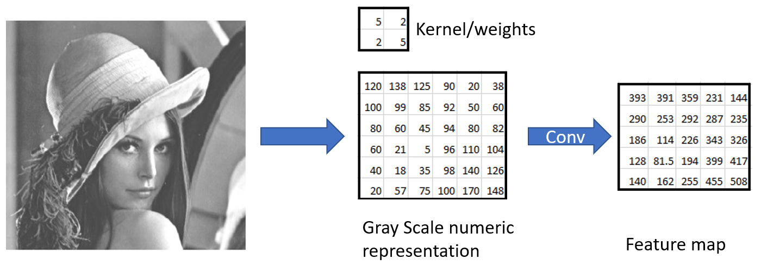

Figure 12 Representation of a convolution over a gray representation of an image

As we can see in Figure 12, the same kernel or weights are applied over all the image, in other words the weights are shared at every location of 4 variables. We can also notice that the local field is a group of four variables all together and after the operation we obtain only one feature for that location. All the features together complete the feature map. In the Figure 12 we can see one example of convolution layer with only one feature extractor (kernel) that generates one feature map but normally a convolution layer has many feature extractors that generate several feature maps.

## Sub-sampling

After having the features map, we will notice that near locations features represent near input locations as well, then an average of near features can be performed and a subsampling as well. This will reduce the resolution of the feature map but will also reduce the sensibility to shifts and distortions [26]. If we continue adding this set of layers convolution plus average-subsampling the effect that we will see is that the number feature maps will keep growing and the spatial resolution will decrease until we end up with a spatial resolution of 1x1. In the following example (Figure 13) proposed by LeCun in 1990 we can see this behavior [26]. Note that the feature is extracted locally from the *same location of* *all the input feature maps or input* and not only one, then that means that we can extend this example if we use 3 or more channels as input.

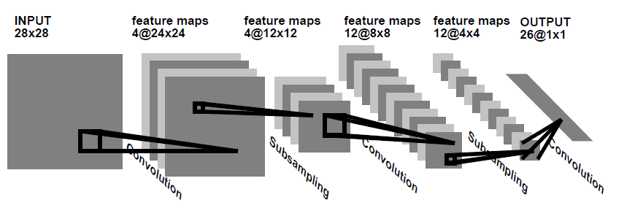

Figure 13 CNN sequence proposed by LeCun

## Fully connected layer

In ML the neural networks layers are staked one over the other. The layers are named input, output and hidden layers. The output of one layer is the result of an activation function applied over linear product of the previous layer output(**x**) [19]. Its weights(**W**) are a matrix of size number_of_inputs_units x numbert_of_output_units, then we can represent the output of one layer as:

output(**x**) = f(**x**) = f(**Wx**) [Formula 1]

Generally, the output layer doesn’t have any activation function [19] because we expect that layer to throw the score that we expect without any modification. Although, if we expect a probabilistic value then a softmax or a sigmoid activation function can be used [18].

Typically, the CNN architecture needs a fixed grid-structure input and will compute features but in order to achieve the classification we still need to use a classic fully connected NN. The fully connected NN will be fed then with the flattened representation 1x1 of the extracted features by the CNN [19].

## CNN Learning

In the same way how the NN are trained it is expected that all the neurons get trained using backpropagation, this is how the CNNs can synthesize their owns feature extractor. The characteristic of weight sharing reduces the memory requirements and add the possibility to parallelize the process [26].

## CNN architectures

## ResNet-152 [8]

In 2015 Haiming He, Ziangyu Zhang Shaoqing Ren and Jian Sun part of the Microsoft Research team reformulated the layers of the CNNs to refer to the input layers and called it residual. This change showed more accuracy when used with depth architectures. Their design won first place in many contests like ImageNet and COCO detection.

Taking the basic theory, staking more and more layers will provide more features and information. Unfortunately, it was discovered that some features started to vanish. A partial solution for this problem is the normalization of the layers. Another problem is related with deep CNN architectures and is that the accuracy gets saturated and not because overfitting reasons. This is the problem that the Microsoft Research team addressed with their residual learning block (Figure 14).

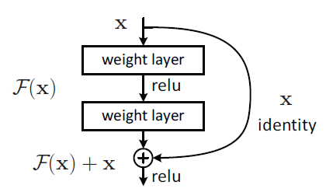

Figure Residual learning block

This residual block is generated basically creating a shortcut skipping one or more layers and adding the features maps. In the Figure 14 we can see one example were the F(x) is the set Conv-Relu-Conv and the output of this operation is added to the input itself. This doesn’t require more parameters and the computation added is not a lot. Two observations appeared. First, training complexity doesn’t increase a lot, second, the accuracy increases when the depth increased in addition the results were visible in many datasets not only one.

To make the addition it is required that F(x) and x have the same dimensions and number filter, if it is not the case then we need to make a linear projection to match the dimensions. About the shortcuts we can see that the jump is over 2 conv layers, in general, they didn’t saw improvement jumping only one conv layer.

To construct the architecture most of the conv layers are 3x3 filters. Two design principles were taken from VGG. First, all the feature maps with the same dimensions shall have the same number of filters, second, if the feature map size is halved then the number of filters in doubled. In this way the linear projection mentioned before is achieved with a stride of 2. The final layer is a global average pooling. To attend the vanishing a batch normalization (BN) is applied after every Conv layer.

Table Resnet architectures

|  |  |  |  |  |  |  |
| --- | --- | --- | --- | --- | --- | --- |
| Layer name | Output size | 18-layer | 34-layer | 50-layer | 101-layer | 152-layer |
| Conv1 | 112x112 | 7x7, 64, stride 2 | | | | |
| Conv2_x | 56x56 | 3x3 max pool, stride 2 | | | | |
| [3x3,64 3x3,64]  x2 | [3x3,64 3x3,64]  x3 | [1x1,64 3x3,64 1x1,256]  x3 | [1x1,64 3x3,64 1x1,256]  x3 | [1x1,64 3x3,64 1x1,256]  x3 |
| Conv3_x | 28x28 | [3x3,128 3x3,128]  x2 | [3x3,128 3x3,128]  x4 | [1x1,128 3x3,128 1x1,512]  x4 | [1x1,128 3x3,128 1x1,512]  x4 | [1x1,128 3x3,128 1x1,512]  x8 |
| Conv4_x | 14x14 | [3x3,256 3x3,256]  x2 | [3x3,256 3x3,256]  x6 | [1x1,256 3x3,256 1x1,1024]  x6 | [1x1,256 3x3,256 1x1,1024]  x23 | [1x1,256 3x3,256 1x1,1024]  x36 |
| Conv5_x | 7x7 | [3x3,512 3x3,512]  x2 | [3x3,512 3x3,512]  x3 | [1x1,512 3x3,512 1x1,2048]  x3 | [1x1,512 3x3,512 1x1,2048]  x3 | [1x1,512 3x3,512 1x1,2048]  x3 |
|  | 1x1 | Average pool, 100-d fc, softmax | | | | |
| FLOPs | | 1.8x109 | 3.5 x109 | 3.8 x109 | 7.6 x109 | 11.3 x109 |

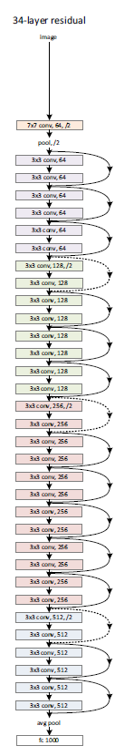

Figure 34-layer Resnet architecture

We can notice that for deeper architectures a sequence 1x1-3x3-1x1 is applied, this is called a bottleneck architecture, the first 1x1 reduces the number of feature maps to make the 3x3 less heavy and the 1x1 restore the number of feature maps.

## InceptionV3 [9]

In 2016 Christian Szegedy, Vincent Vanhoucke, Sergey Ioffe, Hon Schlens and Zbignew Wojna in a collaboration between Google Research team and University College London did a research to optimize the resources in CNN architectures. Previous works like Resnet in 2015 was achieved to increase the quality of the architectures making them deeper. Nevertheless, there are areas like mobile and big data were the memory and speed are still an important factor, then they explored a way to keep the efficiency and reduce the parameters and computation cost by factorizing the convolutional layers and aggressive regularization.

This new architecture was called inception and its computational cost is much lower than a VGG architecture for example. This benefit is achieved optimizing certain operations, although this add more complexity to the architecture. Because the complexity of the architecture it is difficult to adapt or adjust.

Some design principles were used for this architecture. The first design principle is to avoid bottlenecks that extremely compress the information. It can be basically understood that we cannot loss information before a conv layer. Maybe we will think that the Resnet bottleneck block is violating this principle, but it isn’t. They just exchange dimension with number of feature maps before the conv filter. Then another exchange is applied to take the feature maps to the expected quantity.

The second is the essence of the CNN and is a gradual reduction of the feature’s maps size from layer to layer and the increasing of filters every layer to have more disentangled features. The third principle is reducing the feature maps before a NxN convolution. One example is the bottle neck block presented in Resnet. The last principle is to keep a balance between depth and width of the architecture, the optimal improvement of a constant amount of computation can be reached if both are increased in parallel.

The biggest modification applied in Inception architectures was the factorization of large size filters. For example, we can divide a 5x5 filter in two 3x3 filters, but we can even go further and divide the 3x3 into one 1x3 and one 3x1 filter in this way we will have 12 parameters instead of 25 that is less than the half.

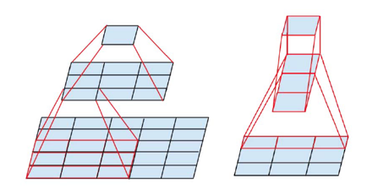

Figure 16 Left side, factorization of a 5x5 conv grid into two 3x3 conv grid. Right side: factorization of a 3x3 conv grid into one 1x3 conv grid followed by a 3x1 conv grid

In summary we can replace any NxN filter with combinations of 1xn and nx1 filters although the research saw that it has good result in medium grid layers with dimension MxM when M is between 12 and 20.

Another reduction that can be performed is to reduce the computational cost. For example, when we have k features maps as inputs with dimension d and we want to use a conv-average pool layer to reduce the dimension of the output to the halve (d/2) and double the number of features maps (2k). The first step is to duplicate k with the conv layer one stride. That means that to get one output feature map it is needed to compute every single variable of the input (kd2) and we want 2k number of feature maps then in total the operations for the conv layer will be 2k2d2. For the average pooling the number of operation are going to be using a 2x2 window with stride of 2 and applied every feature map then the computation is 2k(d/2)2. If we invert the order (average pool -conv layer) we first apply the average pooling that requires k(d/2) operations plus 2k2(d/2)2 because the dimension has already been halved then we can see that the computation cost is almost a quarter than the former proposal. Although we are violating the first principle of this section that is avoid bottlenecks.

To avoid this mentioned loss of information produced by violating the bottleneck principle, they proposed to perform the avg pooling and the conv (with stride of 2 instead of 1) in parallel and then concatenate the results.

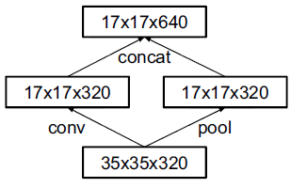

Figure 17 Inception block

Following all these design principles the architecture InceptionV3 was constructed as we can see in the Table 6

Table InceptionV3 architecture

|  |  |  |
| --- | --- | --- |
| type | Patch size/stride or remarks | Input size |
| conv | 3x3/2 | 299x299x3 |
| conv | 3x3/1 | 149x149x32 |
| Conv padded | 3x3/1 | 147x147x32 |
| pool | 3x3/2 | 147x147x64 |
| conv | 3x3/1 | 73x73x64 |
| conv | 3x3/2 | 71x71x80 |
| conv | 3x3/1 | 35x35x192 |
| 3xInception | Inception block 1 | 35x35x288 |
| 5xInception | Inception block 2 | 17x17x768 |
| 2xInception | Inception block 3 | 8x8x1280 |
| pool | 8x8 | 8x9x2048 |
| Linear | Logits | 1x1x2048 |
| softmax | classifier | 1x1x1000 |

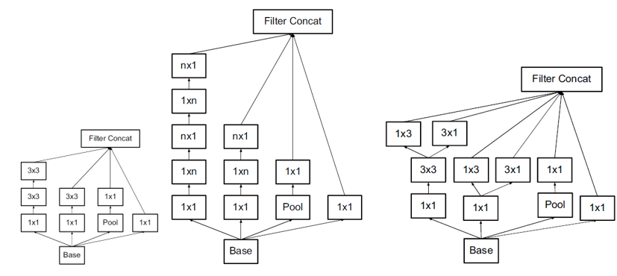

Figure 18 Left side: Inception block 1. Center: Inception block 2. Right side: Inception block 3.

As we can see in Table 6 the classical 7x7 conv layer at the input was replaced with three 3x3 layers. The rest of the layers followed the design principles explained in this section. About the size of the input experiments were done with 299x299, 251x251 and 79x79 and the best results were achieved with the input 299x299.

Table 7 Accuracy results using different input dimesions

|  |  |
| --- | --- |
| Receptive Field size | Top-1 accuracy (single frame) |
| 79x79 | 75.2% |
| 151x151 | 76.4% |
| 299x299 | 76.6% |

## Xception [10]

François Chollet that is the developer of Keras inspired by the Inception architecture designed the Xception architecture. The change was basically replacing the inception modules by depth wise separable convolutions. The architecture has the same number of parameter and apparently use them more efficiently.

To understand the Xception hypothesis first we have to understand two concepts, cross-channel and spatial correlation. The dimensions of the filters are not assigned randomly, we rather use odd dimensions to center de result in one point, having even dimension will make difficult to assign the result of the computation of the input and map it to one output. Having a dimension over 7 will mean a costly computation and they are normally not used.

Although, there is a special dimension 1x1. This is the cross-channel correlation because the filter of dimension 1x1xk (considering k the number of input feature maps or channels) generates a linear combination of the features in one point or pixel (if we are talking about the input). For example, we can take from an image just the channel red if we apply the filter [1,0,0] and we can convert from RGB to gray scale with the proportion [0.2121*red, 0.7152*green, 0.722*blue]. This two different filters or feature extractors can generate two different features maps at the output with cross-channel correlation.

On the other hand, we have the spatial correlation that is achieved with any NxN filter when N is bigger that 1. We call this spatial correlation because these filters extract spatial features like horizontal or vertical lines. Although if we apply a 1x1 immediately after a spatial correlation then we are projecting the features into a new channel space this is called depth wise separable convolutions.

The main Inception hypothesis is that cross-channel and spatial correlation are enough decoupled that is better not map them together. We can visualize this hypothesis in the Figure 18 were the last two branches only work with the 1x1 filter on the other hand the first two branches additionally execute a NxN or its fractioned version Nx1 plus 1xN.

Then two main changes were proposed by François. First, to use depth wise separable convolutions instead the first two branches of the Inception blocks of the Figure 18 and remove the ReLU operation that is following every spatial and cross-channel operation.

With the first change François took the Inception hypothesis even further because spatial and cross-channel correlations are now totally decoupled.

The Xception architecture then has 36 convolutional layers that have separable convolutions all with residual connections as used in Resnet excepting the first and last convolution.

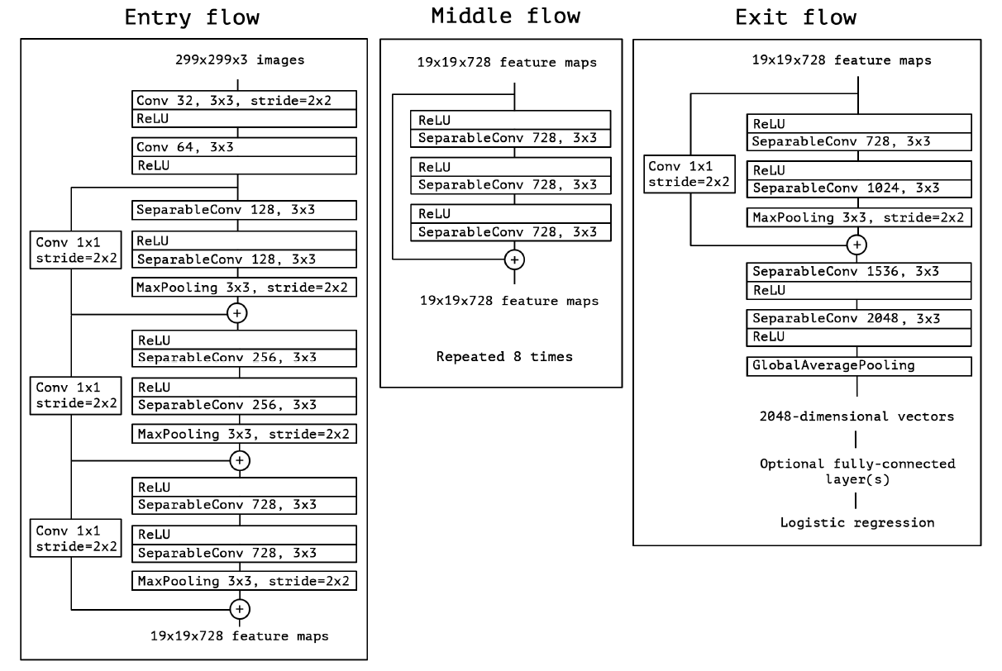

Figure Xception architecture

Residual connections seem to be quite important. An efficiency analysis over imageNet dataset showed a and improvement from 60% to 80%. Removing ReLU resulted in faster convergence a better performance.

## DenseNet-161 [11]

In 2017 Gao Huang, Zhuang Liu, Laurens van der Maaten and Kian Q. Weinberger as part of a collaboration between Facebook AI Research and Cornell University designed the architecture DenseNet. It has the particularity to use the feature maps of all the preceding layers as inputs with the goal to reduce the vanishing problem, strengthen feature propagation and reuse. In addition to reduce the number of parameters.

The vanishing problem is quite common in deep architectures. Many researches have been related to this problem and all of them share the characteristic to create short paths from previous layers. In this architecture they decided basically to connect all the layers. The difference in the shortcuts is that for example ResNet adds the previous feature map on the other hand DenseNet concatenates all the previous ones.

It is expected to require less parameters because there is no need to relearn redundant feature maps. In ResNet the information is preserved by adding although many feature maps contribute very little. This can be confirmed because in their investigation they improved the training applying dropout [8]. ResNet is also quite heavier than DenseNet. DenseNet is easy to train and reduces the overfitting with small train datasets.

Since ResNet, it was assumed that increasing the depth will increase the accuracy. There is another solution that is increasing the width adding more feature maps although DenseNet focus on the reuse. About complexity, DenseNet is less complex than Inception.

To construct the architecture in the layer L we are going to apply a transformation HL over the concatenation of all the previous layers xL= HL([x0,x1,…, xL-1]). In this case H will be a combination BN-ReLU-Conv(3x3). Nevertheless, this operation requires that all the layers have the same size or dimension. DenseNet design principle violates the main principle of the CNNs that is reduce the size of the features maps gradually. Then the proposal solution is to construct Dense blocks that follows the described formula and between these blocks a transition block will be applied to reduce the features maps size. The transition layer will have the format BN-Conv(1x1)-average pooling (2x2). At the transition layer a data compression (θ = 0.5) is also applied to reduce the number of feature maps. Finally, the growth rate, every HL, k features map will be added.

A bottleneck layers 1x1 is applied like in ResNet and Xception. Before every HL operation a reduction of feature maps is applied using the same format as HL that is BN-ReLU-Conv(1x1).

Following this design principles, the DenseNet is constructed and we can see its variants in the Table 8.

Table DenseNet architectures

|  |  |  |  |  |  |
| --- | --- | --- | --- | --- | --- |
| Layers | Output size | DenseNet-121(k=32) | DenseNet-169(k=32) | DenseNet-201(k=32) | DenseNet-161(k=32) |
| Convolution | 112x112 | 7x7 conv,stride2 | | | |
| Pooling | 56x56 | 3x3 max pool, stride 2 | | | |
| Dense Block (1) | 56x56 | [1x1conv 3x3cov] x 6 | [1x1conv 3x3cov] x 6 | [1x1conv 3x3cov] x 6 | [1x1conv 3x3cov] x 6 |
| Transition Block (1) | 56x56 | 1x1 conv | | | |
| 28x28 | 2x2 average pool, stride 2 | | | |
| Dense Block (2) | 28x28 | [1x1conv 3x3cov] x 12 | [1x1conv 3x3cov] x 12 | [1x1conv 3x3cov] x 12 | [1x1conv 3x3cov] x 12 |
| Transition Block (2) | 28x28 | 1x1 conv | | | |
| 14x14 | 2x2 average pool, stride 2 | | | |
| Dense Block (3) | 14x14 | [1x1conv 3x3cov] x 24 | [1x1conv 3x3cov] x 32 | [1x1conv 3x3cov] x 48 | [1x1conv 3x3cov] x 36 |
| Transition Block (3) | 14x14 | 1x1 conv | | | |
| 7x7 | 2x2 average pool, stride 2 | | | |
| Dense Block (4) | 7x7 | [1x1conv 3x3cov] x 16 | [1x1conv 3x3cov] x 32 | [1x1conv 3x3cov] x 32 | [1x1conv 3x3cov] x 24 |
| Classification layer | 1x1 | 7x7 global average pool | | | |
|  | 1000D fully connected, softmax | | | |

## Classification Metrics

## Accuracy

In general, accuracy is the number of items well classified over the total number of inputs. If we want to evaluate the accuracy over a class, we need to evaluate the number of items of such class well classified over the total of inputs of such class [17].

## Precision

The precision is evaluated over the class and it is the number of items that were well classified of such class over the total of predictions that denoted this class [19][27].

## Recall

The Recall is evaluated over the class and it is the number of items that were well classified of such class over the real number of inputs of this class [19][27].

## F1-Score

Normally a model in the way how it gets more precision it starts reducing the recall the ideal is to have a balance. F1-Score follows the following formula:

F1-Score = 2 * (precision * recall) / (precision + recall)

The highest value will be F1-Score = precision = recall. In other words, F1-Score measure the valance between precision and recalls of a class prediction [28][29].

## Macro-F1

Macro-F1 is the average value of all the F1-Score values of all the classes to predict [28][29].

## Hamming Loss

Hamming Loss is the number of items wrong predicted over the total of inputs [30].

## Jaccard Score

Jaccard Score or Jaccard similarity coefficient score is the relationship for a class between the times that it was well predicted against all the times that class appears in the classifications. For example if we have one input like {0,1,2,2} and the prediction is the following {0,2,1,2} for the class number 2 the correct predictions is just one, and the times that appear in the classification as input or as prediction is 3 then the Jaccard score for the class 2 is 1/3. We can get the average Jaccard score for all the classes and get a value for the entire model called Jaccard Score macro. Understanding this we can understand Jaccard score as the similarity between the inputs and the predictions considering 0% the minimum when inputs and predictions are totally different and 100% when the accuracy is 100% [31].

## Log loss

Log loss or cross-entropy is a metric quite useful when the prediction is based in probabilities. In general, log loss is the error between the input and the output. Even if the accuracy is 100% if we use prediction based on probabilities there will always be a gap between the input and the output for example if have one image that is dog and a classifier that differs between cat and dogs and it says that the image is 90% dog and 10% cat, then it will be well classified but the error is of 10%. It is applied a log function to avoid handling too small numbers [32][33].

## Machine and Deep Learning libraries

## NumPy

NumPy was created in 2005 as a numerical computing library. It is an open source library that is integrated to python and the releases are approved by the scientific Python community that ensure the long-term wellbeing of the project [34].

NumPy has optimized libraries focused in vectoral and matrixial operations therefore many other libraries are based on NumPy such as TensorFlow and SKlearn. In this project we are going to be widely using such libraries then implicitly NumPy is going to be used.

## TensorFlow and TensorFlow-GPU

TensorFlow (TF) is an opensource library released by Google in 2015 designed to create ML models [35]. TF was developed to enable the developers to easily design from a small model to complex hybrid models. It already has methods to compile and train designed models. The steps of the model can be executed one after the other without problem, this flexibility enable an intuitive debugging that is complicated to achieve in ML. If the addressed model has thousands of variables it is possible to use the parallelization capabilities of the GPU using TensorFlow-GPU, in general the models are hardware independent [36]. TF is mainly supported over Python, but it also has support over javascript(web) and mobile devices.

The compatibility with the GPU requires some drivers and libraries. To begin it is important to have a computer with NVIDIA GPU and its drivers installed. This NVIDIA GPU shall have support to CUDA 3.5 or higher [37][38].

## Keras

Keras was developer in 2015 by Francois Chollet developer and researcher in Google AI. It is the most used Deep Learning framework. Just as TF, it is a framework focused in ML and DL although the level of abstraction is higher and more human related that TF. Initially, Chollet developed Keras for personal purposes but because its practicality and user-friendly API [39][40]. Before Keras was developed many other libraries were used for DL like Torch, Theano and Café. Nevertheless, those previous in libraries the code was a mix between assemble/C++ not easy to use, time consuming and inefficient [39]. Because those differences we can find Keras as the tool used by many winners in competitions of image recognition [40]. Originally, Keras was developed over Theano, although in the same year TF was released then the tool was migrated to work over TF and continue in this way until now [39]. Even when Keras is a complete separate development than TF some stable releases are incorporated to tensorflow libraries and we can find them under the packages *tf.keras* that ensure a complete compatibility.

The advantage that has Keras over TF is that it is a high-level API that simplifies de design of complex models that sometimes have hundreds of layers and in using TF a developer can easily get lost.

## Tensorboard

Tensorboard is a visualization tool focused in the analysis of ML. Using this tool is possible to visualize the metric values of a model as accuracy and loss. We can even visualize the model and probabilistic analysis across the time [41]. To use Tensorboard it is required to create a callback that is going to be logging events and results along the training [42].

## Pandas

Pandas was developed first by AQR Capital Management that is a financial enterprise in 2008. Pandas is a library designed for the data frame handling. This tool makes easy to read from some common formats as CSV, excel, SQL databases and creates data frames [43]. It even handles the read data to avoid missing data and alignment. Just as NumPy this library is optimized because critical parts of the code were developed in C. Pandas is developed in Python as a high-level API for data analysis [43].

## SKLearn

SKLearn that is an acroning science Kit Learn was released in 2010 by Fabian Pedregosa, Gael Varoquax, Alexandre Gramfort and Vincent Michel. SKLearn is a high-level API designed over Python that has APIs related with Clustering, Composite and Covariance Estimators, metrics and other ones all related to data science [44]. The libraries have dependency of NumPy.

# DESARROLLO METODOLÓGICO

**Resumen:** [En este capítulo se presenta en detalle el desarrollo metodológico que incluye [pasos o proceso a seguir] un resumen de los trabajos relacionados con [el objeto de estudio].]

## Levantamiento de requerimientos

[En esta sección se incluye la metodología de trabajo elegida para el desarrollo de la propuesta. Si el trabajo es un desarrollo de software, se podría elegir una metodología como “agile”, cascada, espiral, prototipado, incremental, RAD (Rapid Application Development, u otra relacionada con el desarrollo de software. Si es para el desarrollo de aplicaciones web podría utilizarse RMM (Relationship Management Methodology), OOHDM (Object Oriented Hypermedia Design Method), UWE (UML-Based Web), entre otros. y en esta sección se pondrían los títulos y subtítulos con los tipos XXXXX. Metodologías de Investigación podrían contener la definición teórica, metodologías o métodos formales de solución, métodos de simulación, entre otros DEFINIDOS Y SELECCIONADOS POR LOS TUTORES.]

# RESULTADOS Y DISCUSIÓN

**Resumen:** [En este capítulo se presentan los resultados obtenidos del desarrollo de este trabajo y una discusión sobre [el objeto de estudio]].

## Resultados

[Teclee los resultados en pasado. Ponga título a sus tablas y gráficos. Hacer referencia explícita utilizando la numeración. Ejemplo: …, como se muestra en la Figura 10. NO referenciar mencionado: como en la siguiente figura, o similar.]

## Discusión

[resultados más relevantes de este trabajo, los más relevantes de otros trabajos, comparar, referir a nuevos trabajos que puedan surgir de aquí, o problemas.

# CONCLUSIONES

**Resumen:** [En este capítulo se presentan las conclusiones y trabajo futuro en relación a [el objeto de estudio]].

## Conclusiones

[Las conclusiones deben responde a los objetivos establecidos]

## Future Works

1) In the section of methodology subsection Hyperparameter are described some steps that where execute manually in order to find the best learning rate per model, such model can be automated.

2) This investigation was performed using only the three basic bands RGB as suggested by [7] but may papers in the State of the Art section shows that it is also possible to use more band to obtain even more information, then for future work it is planned to use more bands starting with ones that detects water in order to improve the classification hoping to also improve significantly the classification of disasters.

BIBLIOGRAFÍA

[Bibliografía Estilo IEEE: <http://www.ieee.org/documents/ieeecitationref.pdf>

El orden de la bibliografía debe ser el orden en el que aparece en el documento. Toda bibliografía puesta en esta sección deberá estar citada dentro del texto. La forma de hacer la cita cuando es una sola es [1], si son varias y salteadas es [3], [5], [8]. Si son varias consecutivas es [5]-[8]. Combinadas es [2]-[6], [9].

El formato de la bibliografía es como lista numerada simple, sin tabla.

El formato de cada una es como se describe a continuación y dependiendo del tipo:

*[Book Article*

* *For an article in an edited book, use practice similar to that for*[*author w/ editor or translator*](http://www.edshare.soton.ac.uk/77/1/bbieee-help.html#auth-ed/trans)*above, inserting article title between author[s] names and book title.*
* *[Citation Number] Author name[s], "*[*article title*](http://www.edshare.soton.ac.uk/77/1/bbieee-help.html#title-art)*," in*[*book title*](http://www.edshare.soton.ac.uk/77/1/bbieee-help.html#title)*,*[*editor names*](http://www.edshare.soton.ac.uk/77/1/bbieee-help.html#auth-ed/trans)*, publication location: publisher, year,*[*pages.*](http://www.edshare.soton.ac.uk/77/1/bbieee-help.html#pages)
* *Examples:]*

1. E.D. Lipson and B.D. Horowitz, "Photosensory reception and transduction," inSensory Receptors and Signal Transduction, J.L. Spudich and B.H. Satir, Eds. New York: Willey-Liss, 1991. pp. 1-64.
2. J. Lacan. "The insistence of the letter in the unconscious," in Psychoanalysis and Language, David Lodge, Ed., J. Rose, Trans., Ithaca, NY: Cornell University Press, 1992, pp. 123-34.

*[Journal*

* *[Citation Number] Author name[s], "*[*article title*](http://www.edshare.soton.ac.uk/77/1/bbieee-help.html#title-art)*,"*[*journal title*](http://www.edshare.soton.ac.uk/77/1/bbieee-help.html#title-per)*,*[*volume number, issue number, month (abbrv.)*](http://www.edshare.soton.ac.uk/77/1/bbieee-help.html#volume)*,*[*pages*](http://www.edshare.soton.ac.uk/77/1/bbieee-help.html#pages)*, publication year.*
* *Only include information which is pertinent to your source.  For example, many professional and academic journals do not have an issue month.  In that case, or when it seems unnecessary, do not include it in your citation.*
* *Examples:]*

1. K.A. Nelson, R.J. Dwayne Miller, D.R. Lutz, and M.D. Fayer, "Optical generation of turntable ultrasonic waves," Journal of Applied Physics, vol. 53, no. 2, Feb., pp. 1144-1149.
2. J. Allemang, "Social studies in gibberish," Quarterly Reviews of Doublespeak, vol. 20, no. 1, pp. 9-10.

*[Popular Periodical Article (monthly or bimonthly)*

* *In the case of popular monthly or bimonthly periodicals, omit volume number and issue, identifying instead by month and year of publication.*
* *[Citation Number] Author name[s], "*[*article title*](http://www.edshare.soton.ac.uk/77/1/bbieee-help.html#title-art)*,"*[*periodical  title*](http://www.edshare.soton.ac.uk/77/1/bbieee-help.html#title-per)*,*[*month (abbrv.)*](http://www.edshare.soton.ac.uk/77/1/bbieee-help.html#volume)*,*[*pages*](http://www.edshare.soton.ac.uk/77/1/bbieee-help.html#pages)*, publication year.*
* *Examples:]*

1. J. Fallows, "Network technology," Atlantic Monthly, Jul., pp. 34-36, 1994.

*[Popular Periodical Article (Biweekly, weekly, or daily)*

* *In the case of more frequently published periodicals, use day, month, and year to identify.*
* *[Citation Number] Author name[s], "*[*article title*](http://www.edshare.soton.ac.uk/77/1/bbieee-help.html#title-art)*,"*[*periodical  title*](http://www.edshare.soton.ac.uk/77/1/bbieee-help.html#title-per)*,*[*day number month (abbrv.)*](http://www.edshare.soton.ac.uk/77/1/bbieee-help.html#volume)*,*[*pages*](http://www.edshare.soton.ac.uk/77/1/bbieee-help.html#pages)*, publication year.*
* *Examples:]*

1. B. Metcalfe, "The numbers show how slowly the Internet runs today," Infoworld, 30 Sep., p. 34, 1996.
2. J. Turner, "Disorder 'kills without warning,'" The Toronto Star, 26 Jun., pp. F1-F2, 1998.

*[Paper Published in Conference Proceedings or Presented at Conference*

* *Treat a presentation in conference proceedings like an article in an edited book, including all available publication information.  Conference proceedings are often published by the organization holding the conference; in that case, do not cite the publisher.*
* *Example:]*

1. Paez-Borrallo, I.A. Perez-Alavarezz, and S.Z. Bello, "Adaptive foltering in data communications with self improved error reference," in Proc. IEEE ICASSP '94, 1994, pp. 65-68.

*[Treat an unpublished paper presented as a conference in the following manner: [Citation Number] Author name[s], "*[*article title*](http://www.edshare.soton.ac.uk/77/1/bbieee-help.html#title-art)*," presented at conference title. conference location, year.*

* *Example:]*

1. M. Lai, B. Chen, and S. Yuan, "Toward a new educational environment," presented at 4th Int. World Wide Web Conf. Boston, MA, 1995.

*[Web Page*

* *Give the author, title, type of medium (enclosed in brackets), volume and issue number (if on-line journal), page number (if relevant or given), and the year and the month of publication (in parentheses).  Then give the full internet address or the name of the online service provider prefaced by "Available at ".  If not an on-line journal, also put [cited year month day] before "Available at".*
* *Examples:]*

1. A. Harnack and G. Kleppinger, "Beyond the MLA Handbook: Documenting Electronic Sources on the Internet." Kairos, [Online serial] 1 (2), (1996 Sum), Available at HTTP: http://english.ttu.edu.kairos/1.2/
2. P. Curtis, "Mudding: Social Phenomena in text-based virtual realities," [Online document] Aug. 1992, [1996 Aug 30], Available at FTP: parcftp.xerox.com/pub/MOO/papers/DIAC921992.

**\*\*\*\*\*\*\*\*El estilo es Referencia**]

[1]<https://www.eleconomista.com.mx/estados/Fonatur-establece-el-costo-del-rentable-Tren-Maya-en-139072-millones-de-pesos-20200108-0081.html>

[2]<https://www.eleconomista.com.mx/empresas/Otorgarian-41300-millones--de-pesos-a-Dos-Bocas-20190909-0020.html>

[3] Documento de gus

[4] <https://imco.org.mx/nuevo-aeropuerto-internacional-mexico-proyecto-indispensable-riesgos-oportunidades/?gclid=Cj0KCQjwoub3BRC6ARIsABGhnyaN_vz4zxgkBnO6F3yAd4wnMyOKJSef3mj3_6oBdoxmFo8RlrTva7EaAk6JEALw_wcB>

[5]<https://www.neworleanssaints.com/news/construction-firm-for-renovations-to-mercedes-benz-superdome-approved-renderings>

[6]<http://www.image-net.org/challenges/LSVRC/>

[7] Satellite Image Classification with Deep Learning

Resnet-152 [8],

InceptionV3[9],

Xcepetion [10]

DenseNet-121[11].

[12] Functional Map of the World

[13] A novel two-tier paradigm for labeling water bodies

[14] DEEP LEARNING NEURAL NETWORKS FOR LAND USE LAND COVER MAPPING

[15] Dense Cloud Classification on Multispectral

[16] Improved Machine Learning Methodology for High Precision Agriculture

[17] Pattern Recognition Scheme for Large-Scale Cloud

[18] Satellite Image Classification with Deep Learning

[19] Deep Learning for Cloud Detection

[20] <https://blogs.oracle.com/bigdata/difference-ai-machine-learning-deep-learning>

[21] <https://www.history.com/news/7-early-robots-and-automatons>

[22] Singh, Gyanendra & Vedrtnam, Ajitanshu & Sagar, Dheeraj. (2013). AN OVERVIEW OF ARTIFICIAL INTELLIGENCE. 10.13140/RG.2.2.20660.19840.

<https://www.researchgate.net/publication/236346414_AN_OVERVIEW_OF_ARTIFICIAL_INTELLIGENCE>

[23] <https://medium.com/ml-ai-study-group/ai-mind-map-a70dafcf5a48>

[24] An introduction to Neural Networks

[25] Ekins, S. The Next Era: Deep Learning in Pharmaceutical Research. *Pharm Res* **33,**2594–2603 (2016). <https://doi.org/10.1007/s11095-016-2029-7>

<https://link.springer.com/article/10.1007/s11095-016-2029-7>

[26] Convolutional Networks for Image, Speech, and Time-Series

[27] <https://towardsdatascience.com/multi-class-metrics-made-simple-part-i-precision-and-recall-9250280bddc2>

[28] <https://towardsdatascience.com/multi-class-metrics-made-simple-part-ii-the-f1-score-ebe8b2c2ca1>

[29] <https://scikit-learn.org/stable/modules/generated/sklearn.metrics.f1_score.html#sklearn.metrics.f1_score>

[30] <https://scikit-learn.org/stable/modules/generated/sklearn.metrics.hamming_loss.html#sklearn.metrics.hamming_loss>

[31] <https://scikit-learn.org/stable/modules/generated/sklearn.metrics.jaccard_score.html#sklearn.metrics.jaccard_score>

[32]  [<https://scikit-learn.org/stable/about.html>](https://towardsdatascience.com/log-loss-function-math-explained-5b83cd8d9c83)

[33] https://scikit-learn.org/stable/modules/generated/sklearn.metrics.log_loss.html#sklearn.metrics.log_loss

[34] <https://numpy.org/about/>

[35] <https://www.tensorflow.org/overview>

[36] <https://www.tensorflow.org/about>

[37] <https://www.tensorflow.org/install/gpu>

[38] <http://bailiwick.io/2017/11/05/tensorflow-gpu-windows-and-jupyter/>

[39] <https://www.pyimagesearch.com/2019/10/21/keras-vs-tf-keras-whats-the-difference-in-tensorflow-2-0/>

[40] <https://keras.io/>

[41] <https://www.tensorflow.org/tensorboard>

[42] <https://www.tensorflow.org/api_docs/python/tf/keras/callbacks/TensorBoard>

[43] <https://pandas.pydata.org/about/index.html>

[44] <https://scikit-learn.org/stable/about.html>

**APÉNDICE A. Título**

**APÉNDICE B. Título**